Exercise: Spring Framework

1 Write a program to demonstrate Tightly Coupled code.

Answer:

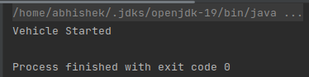

2 Write a program to demonstrate Loosely Coupled code.

Answer:

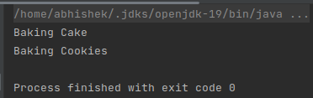

3 Use @Compenent and @Autowired annotations to in Loosely Coupled code for dependency management

Answer:

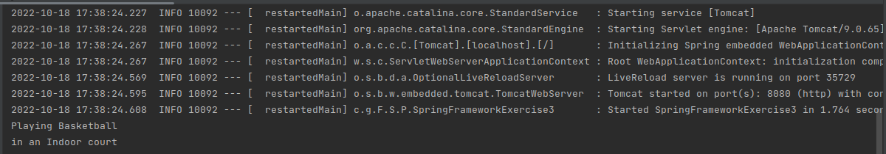

4 Get a Spring Bean from application context and display its properties.

Answer:

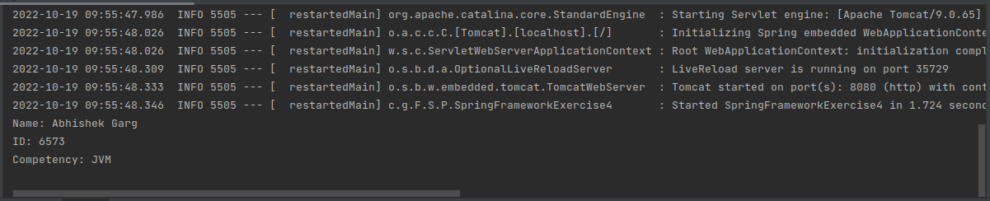

5 Demonstrate how you will resolve ambiguity while autowiring bean (Hint : @Primary)

Answer:

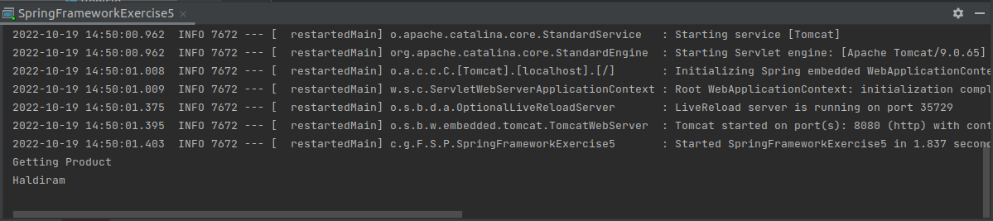

6 Perform Constructor Injection in a Spring Bean

Answer:

